**Week: 3**

**Understanding Working of HTTP Headers**

**Question:** Understand working of HTTP headers

Conditional Get: If-Modified-Since

HTTP Cookies: Cookie and Set-Cookie

Authentication: Auth-Basic

Design a web page that has one embedded page (e.g. image) and sets a cookie and enables authentication. You are required to configure the web server (e.g. apache) with authentication mechanism. Show the behavior of conditional get when embedded objects are modified and when it is not (you can just change the create date of the embedded object). Decode the BasicAuth header using Base64 mechanism as per the password setup.

**Observation**: Show the behavior of browser when is cookie is set and when cookie is removed.

**Solution:** Analyzing Basic Authentication and Cookies

The three parts of experiment are:

1. Password Authentication
2. Cookie Setting
3. Conditional get

**Steps of Execution (for Password Authentication)**

1. Executing the below commands on the terminal.

--> To update and integrate the existing softwares **sudo apt-get update**

--> To install the apache utility **sudo apt-get install apache2 apache2-utils**

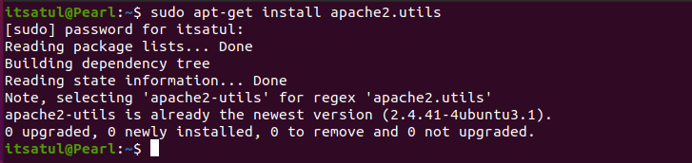

--> Provide username and password to set authentication **sudo htpasswd -c /etc/apache2/.htpasswd ANY_USERNAME**

Here “netwo” is the username. Also, password is entered twice.

--> View the authentication **sudo cat /etc/apache2/.htpasswd**

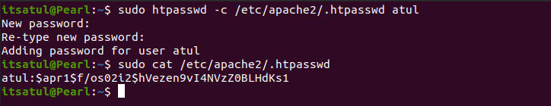

2. To setup the authentication phase, execute the following commands. Configuring Access control within the Virtual Host Definition.

--> Opening the file for setting authentication **sudo nano /etc/apache2/sites-available/000-default.conf**

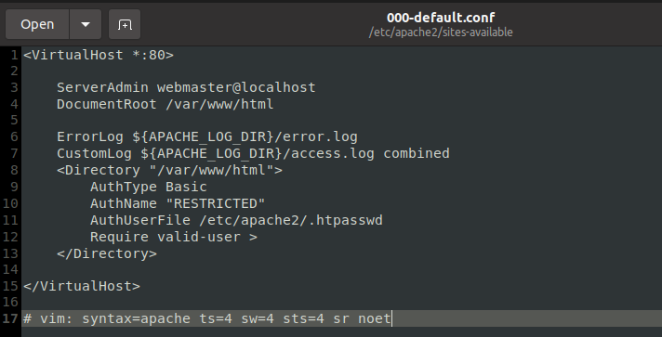

1. Password policy implementation is done by restarting the server as:

**sudo service apache2 restart**



1. The localhost is then accessed using the Firefox browser requiring a username and a password set during the authentication phase.

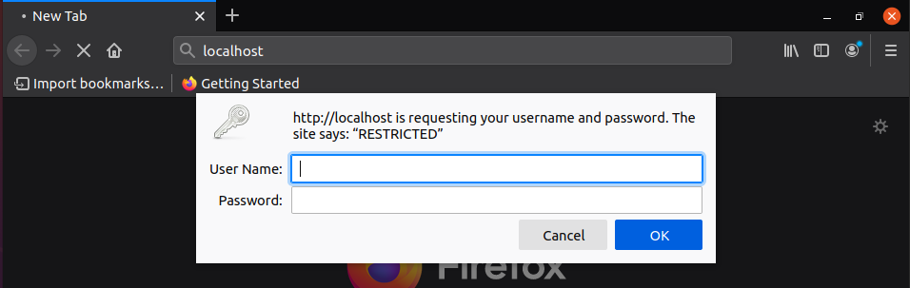

1. Wireshark is used to capture the packets sent upon the network.

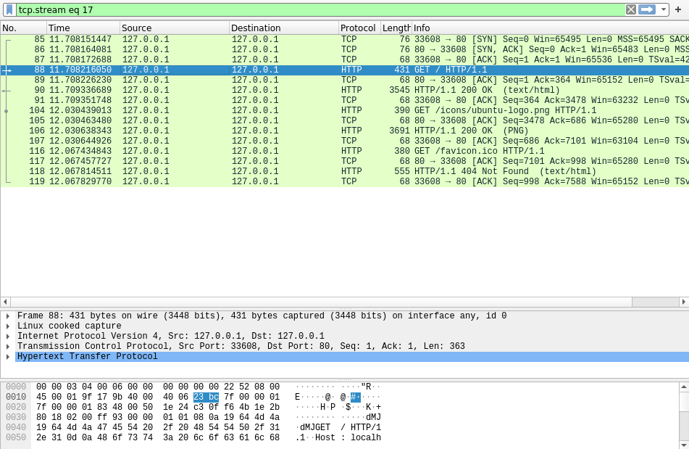

1. Using the “follow TCP stream” on the HTTP message segment the password was retrieved which was encrypted by the base64 algorithm and decryption could be done with same algorithm.

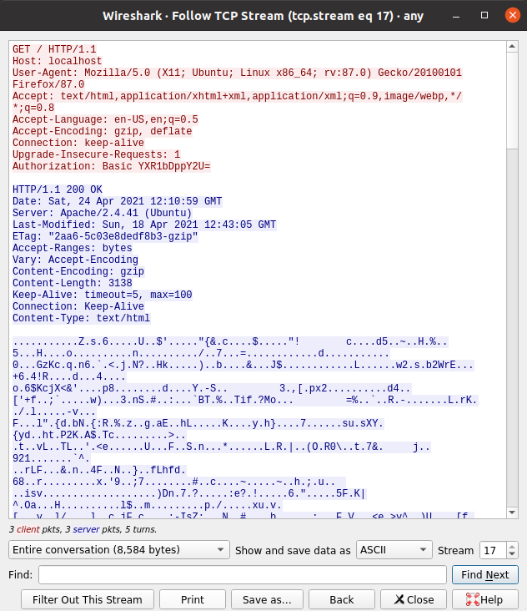

**Steps of Execution (Cookie Setting)**

1. A PHP file to set the cookie is created which also contains an image in it (placed under the HTML directory) to be accessed once the cookie is set. The following code helped to set the cookie:

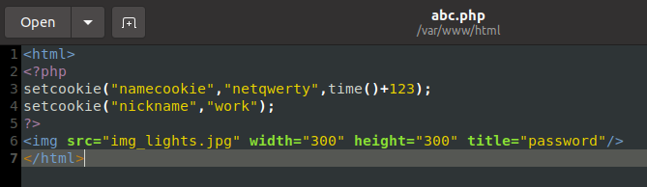

**Note: You can capture Cookies mostly during the first time of web access. Hence keep wireshark capture ready before executing the task for the first time.**

1. The combined file saved with a .php extension is placed under **/var/www/html** for accessing.

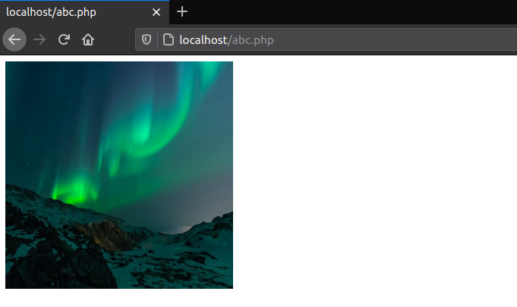

1. The packets are captured using Wireshark and using the “follow TCP stream” which checks for the set-cookie field whether the cookie is set or not set.

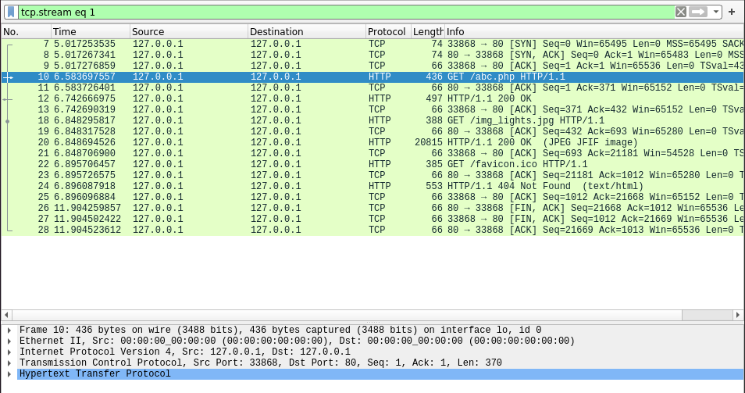

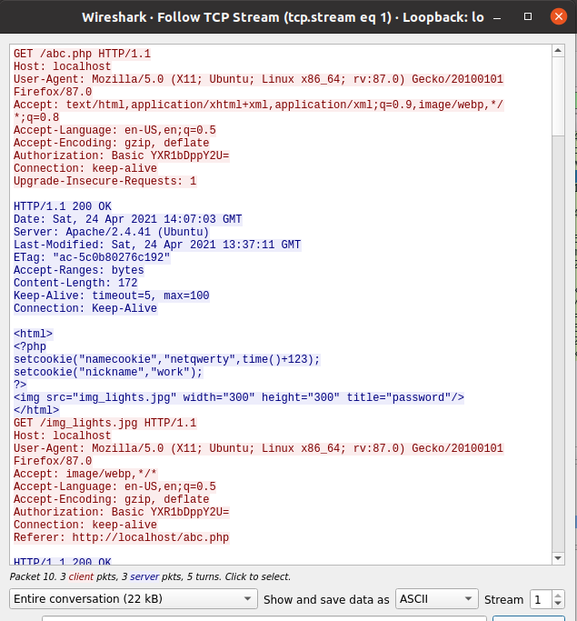

The cookie is set as shown in the above screenshot.

**Observation:** Understand and work out base 64 algorithm and write in your observation. Observe various parameters associated with Cookie in the wireshark capture.

**Conditional Get: If-Modified-Since**

Before performing the steps below, make sure your browser’s cache is empty. (To do this under Firefox, select Tools -> Clear Recent History and check the Cache box). Now do the following: ➢ Start up your web browser, and make sure your browser’s cache is cleared, as discussed above.

* + Start up the Wireshark packet sniffer.
  + Enter the following URL into your browser [http://gaia.cs.umass.edu/wiresharklabs/HTTP-wireshark-file2.html](http://gaia.cs.umass.edu/wireshark-labs/HTTP-wireshark-file2.html)
  + Your browser should display a very simple five-line HTML file.
  + Quickly enter the same URL into your browser again (or simply select the refresh button on your browser)
  + Stop Wireshark packet capture, and enter “http” in the display-filter-specification window, so that only captured HTTP messages will be displayed later in the packetlisting window.

